Міністерство освіти і науки України
Національний технічний університет України «Київський політехнічний інститут імені Ігоря Сікорського"
Факультет інформатики та обчислювальної техніки

Кафедра інформатики та програмної інженерії

Звіт

з комп’ютерного практикуму №1 з дисципліни
«Основи розробки програмного забезпечення на платформі Microsoft.NET»

«LINQ to Objects»

Виконав
(шифр, прізвище, ім'я, по батькові)
Голяка Д.В.

Перевірила

(прізвище, ім'я, по батькові)
Ліщук К.І.

Варіант 16
Умова
Розробити структуру даних для зберігання інформації про скачки та проведені заїзди. Жокей характеризується псевдонімом, прізвищем, ім’ям, по батькові, датою народження. Коні, які беруть участь в перегонах, характеризуються породою, кличкою і віком. Заїзди проводяться в певну дату і час, мають певний номер (в один день може бути проведено кілька заїздів). Учасники заїзду характеризуються номером і зайнятим місцем в заїзді. Під учасником розуміється жокей і кінь, на якому він буде брати участь в заїзді

ER-діаграма
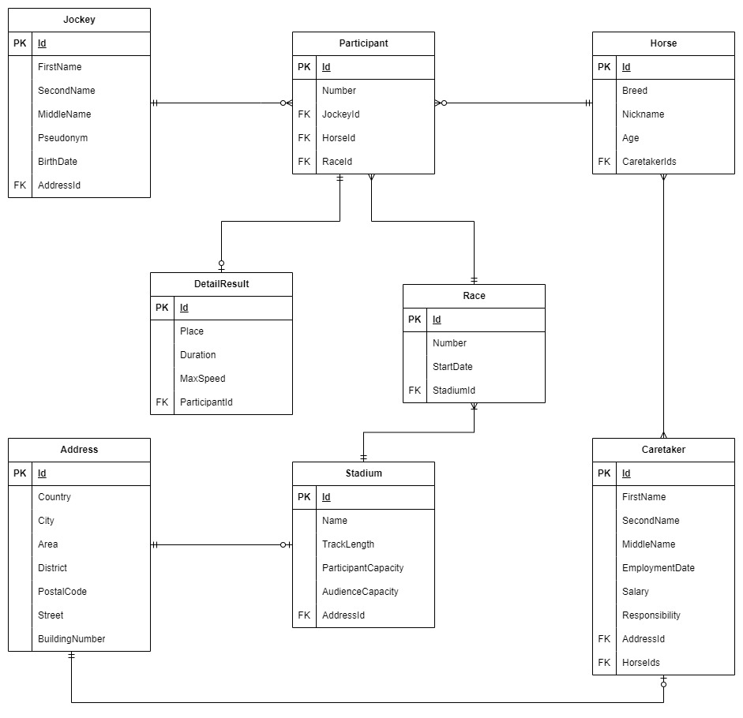

Опис архітектури
Проєкт був декомпозований на наступні каталоги для зручності роботи:
DataCollector – представляє контекст даних, клас, в якому агреговано колекції даниз;
Entities – представляє набір сутностей (адреси, жокеї, коні та інші)
DTO – представляє об’єкти для отримання результату та зручності передачі.
ER-diagram – представляє ER-діаграму заданого предметного середовища
Execution – представляє набір класів для виконання додатку
Inserters – представляє класи для вставки даних у DataContext
Service – допоміжні класи, що відповідають за логіку роботи програми

Більш детально із архітектурою додатку можна ознайомитися за посиланням: GitHub

Запити
/// <summary>
/// Query 1. (Method syntax)
/// Returns a summary of all horses in descending order of age
/// </summary>
public static List<HorseShortInfo> GetHorsesByDescendingAge(List<Horse> horses)
{
List<HorseShortInfo> res = horses
.OrderByDescending(h => h.Age)
.Select(h => new HorseShortInfo()
{
Id = h.Id,
Nickname = h.Nickname,
Age = h.Age
})
.ToList();

return res;
}



/// <summary>
/// Query 2. (Method syntax)
/// Returns addresses from the United States with an odd house number
/// </summary>
public static List<AddressShortInfo> GetFilteredAddresses(List<Address> addresses)
{
List<AddressShortInfo> res = addresses
.Where(a => a.Country == "USA" && a.BuildingNumber % 2 == 1)
.Select(a => new AddressShortInfo()
{
Id = a.Id,
Country = a.Country,
BuildingNumber = a.BuildingNumber,
})
.ToList();

return res;
}



/// <summary>
/// Query 3. (Method syntax)
/// Returns jockeys who live in the specified country
/// </summary>
public static List<JockeyCountryInfo> GetJockeysInCountry(List<Jockey> jockeys, List<Address> addresses, string? country)
{
if (country is null)
{
Console.WriteLine("Country cannot be null");
return [];
}

List<JockeyCountryInfo> res = jockeys
.Join(addresses,
j => j.AddressId,
a => a.Id,
(j, a) => new JockeyCountryInfo()
{
Id = j.Id,
FullName = j.FirstName + ' ' + j.MiddleName + ' ' + j.SecondName,
Country = a.Country
})
.Where(g => g.Country == country)
.ToList();

return res;
}

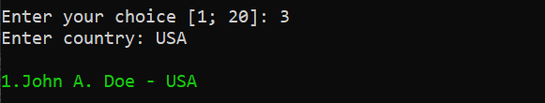

/// <summary>
/// Query 4. (Query syntax)
/// Returns all caretakers who care for more than one horse
/// </summary>
public static List<CaretakerHorseCountInfo> GetCaretakerWithMoreThanOneHorse(List<Caretaker> caretakers)
{
IEnumerable<CaretakerHorseCountInfo> res =
from c in caretakers
let horseCount = c.HorseIds!.Count()
where horseCount > 1
select new CaretakerHorseCountInfo()
{
Id = c.Id,
FullName = c.FirstName + ' ' + c.MiddleName + ' ' + c.SecondName,
Salary = c.Salary,
HorseCount = horseCount
};

return res.ToList();
}

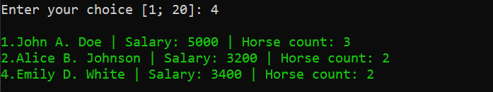
/// <summary>
/// Query 5. (Query syntax)
/// Returns horses that have won more than once
/// </summary>
public static List<HorseWinsInfo> GetHorsesWithMultipleWins(List<Horse> horses, List<Participant> participants, List<DetailResult> results)
{
IEnumerable<HorseWinsInfo> res =
from h in horses
join p in participants on h.Id equals p.HorseId
join r in results on p.Id equals r.ParticipantId
group r by new { h.Id, h.Nickname } into grouped
let winningCount = grouped.Count(r => r.Place == 1)
where winningCount > 1
select new HorseWinsInfo()
{
Id = grouped.Key.Id,
Nickname = grouped.Key.Nickname,
WinningCount = winningCount,
};

return res.ToList();
}


/// <summary>
/// Query 6. (Query syntax)
/// Returns horses that have participated in races
/// </summary>
public static List<HorseShortInfo> GetHorsesInRacing(List<Horse> horses, List<Participant> participants)
{
IEnumerable<HorseShortInfo> res =
from h in horses
join p in participants on h.Id equals p.HorseId
group h by new { h.Id, h.Nickname, h.Age } into horseGroup
select new HorseShortInfo()
{
Id = horseGroup.Key.Id,
Nickname = horseGroup.Key.Nickname,
Age = horseGroup.Key.Age,
};

return res.ToList();
}



/// <summary>
/// Query 7. (Method syntax)
/// Return horses that have not participated in a race
/// </summary>
public static List<HorseShortInfo> GetHorsesWithoutRacing(List<Horse> horses, List<Participant> participants)
{
List<HorseShortInfo> res = horses
.Where(h => participants.Any(p => p.HorseId == h.Id) == false)
.Select(h => new HorseShortInfo()
{
Id = h.Id,
Nickname = h.Nickname,
Age = h.Age
})
.ToList();

return res;
}



/// <summary>
/// Query 8. (Method syntax)
/// Returns jockeys older than the number of years specified by the user
/// </summary>
public static List<JockeyAgeInfo> GetJockeysOlderThan(List<Jockey> jockeys, int age)
{
List<JockeyAgeInfo> res = jockeys
.Where(j => (DateTime.Now - j.BirthDate) > TimeSpan.FromDays(age * 365))
.Select(j => new JockeyAgeInfo()
{
Id = j.Id,
FullName = j.FirstName + ' ' + j.MiddleName + ' ' + j.SecondName,
Age = Math.Round((DateTime.Now - j.BirthDate).Days / 365.25, 2),
})
.ToList();

return res;
}

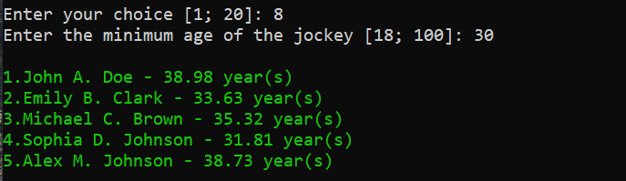

/// <summary>
/// Query 9. (Method syntax)
/// Returns a horse with a record top speed
/// </summary>
public static HorseMaxSpeedInfo? GetBestSpeedHorse(List<Horse> horses, List<Participant> participants, List<DetailResult> results)
{
HorseMaxSpeedInfo? horse = horses
.Join(participants,
h => h.Id,
p => p.HorseId,
(h, p) => new
{
h.Id,
h.Breed,
h.Nickname,
ParticipantId = p.Id
})
.Join(results,
p => p.ParticipantId,
r => r.ParticipantId,
(p, r) => new HorseMaxSpeedInfo()
{
Id = p.Id,
Breed = p.Breed,
Nickname = p.Nickname,
MaxSpeed = r.MaxSpeed,
})
.MaxBy(g => g.MaxSpeed);

return horse;
}



/// <summary>
/// Query 10. (Method syntax)
/// Returns all jockeys and horses by combining the corresponding pairs
/// </summary>
public static List<JockeyHorseInfo> GetJockeysAndHorses(List<Jockey> jockeys, List<Horse> horses, List<Participant> participants)
{
IEnumerable<JockeyHorseInfo> jockeysHorsesLeftJoin = jockeys
.GroupJoin(participants,
j => j.Id,
p => p.JockeyId,
(j, participantGroup) => new
{
JockeyId = j.Id,
FullName = j.FirstName + ' ' + j.MiddleName + ' ' + j.SecondName,
ParticipantGroup = participantGroup,
})
.SelectMany(p => p.ParticipantGroup.DefaultIfEmpty(),
(p, participant) => new
{
p.FullName,
HorseId = participant?.HorseId ?? -1
})
.GroupJoin(horses,
p => p.HorseId,
h => h.Id,
(p, horseGroup) => new
{
p.FullName,
HorseGroup = horseGroup
})
.SelectMany(g => g.HorseGroup.DefaultIfEmpty(),
(p, horse) => new JockeyHorseInfo()
{
FullName = p.FullName,
HorseNickname = horse?.Nickname ?? "<without any horse>"
})
.Distinct();

IEnumerable<JockeyHorseInfo> jockeysHorsesRightJoin = horses
.GroupJoin(participants,
h => h.Id,
p => p.HorseId,
(h, participantGroup) => new
{
HorseNickname = h.Nickname,
ParticipantGroup = participantGroup
})
.SelectMany(p => p.ParticipantGroup.DefaultIfEmpty(),
(p, participant) => new
{
JockeyId = participant?.JockeyId ?? -1,
p.HorseNickname
})
.GroupJoin(jockeys,
g => g.JockeyId,
j => j.Id,
(g, groupJockey) => new
{
g.JockeyId,
g.HorseNickname,
GroupJockey = groupJockey,
})
.SelectMany(p => p.GroupJockey.DefaultIfEmpty(),
(p, jockey) => new JockeyHorseInfo()
{
FullName = (jockey is not null)
? jockey?.FirstName + ' ' + jockey?.MiddleName + ' ' + jockey?.SecondName
: "<without any jockey>",
HorseNickname = p.HorseNickname,
})
.Distinct();

List<JockeyHorseInfo> res = jockeysHorsesLeftJoin.Union(jockeysHorsesRightJoin!).ToList();

return res;
}

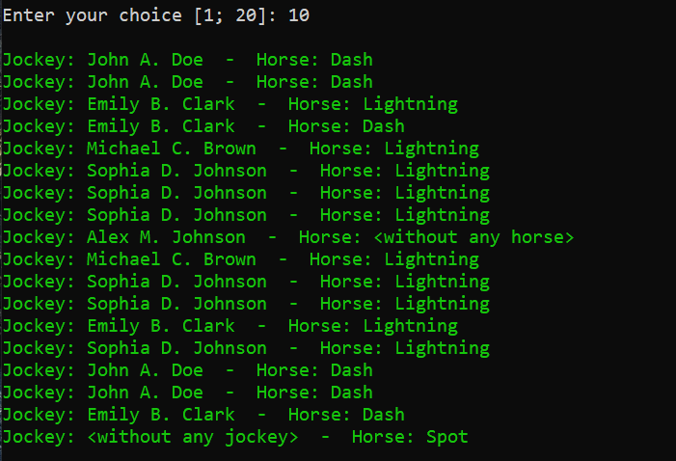

/// <summary>
/// Query 11. (Method syntax)
/// Return the stadium with the longest track
/// </summary>
public static StadiumMaxTrackInfo? GetStadiumWithMaxTrackLength(List<Stadium> stadiums)
{
StadiumMaxTrackInfo? res = stadiums
.Select(s => new StadiumMaxTrackInfo()
{
Id = s.Id,
Name = s.Name,
TrackLength = s.TrackLength
})
.MaxBy(s => s.TrackLength);

return res;
}



/// <summary>
/// Query 12. (Query syntax)
/// Return the caretaker who lives in the specified country and earns more than the specified amount of money
/// </summary>
public static List<CaretakerCountryInfo> GetCaretakersInCountryWithSalaryAbove(List<Caretaker> caretakers, List<Address> addresses, string? country, int salary)
{
if (country is null)
{
Console.WriteLine("Country cannot be null");
return [];
}

IEnumerable<CaretakerCountryInfo> res =
from c in caretakers
where c.Salary > salary
join a in addresses on c.AddressId equals a.Id
where a.Country == country
select new CaretakerCountryInfo()
{
Id = c.Id,
FullName = c.FirstName + ' ' + c.MiddleName + ' ' + c.SecondName,
Salary = c.Salary,
Country = a.Country,
};

return res.ToList();
}

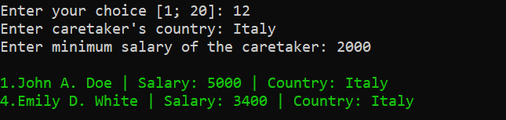
/// <summary>
/// Query 13. (Method syntax)
/// Returns races that took place at a stadium in the specified country
/// </summary>
public static List<RaceCountryInfo> GetRacesInCountry(List<Race> races, List<Stadium> stadiums, List<Address> addresses, string? country)
{
if (country is null)
{
Console.WriteLine("Country cannot be null");
return [];
}

List<RaceCountryInfo> res = races
.Join(stadiums,
r => r.StadiumId,
s => s.Id,
(r, s) => new
{
r.Id,
r.Number,
s.AddressId,
})
.Join(addresses,
at => at.AddressId,
a => a.Id,
(at, a) => new RaceCountryInfo()
{
Id = at.Id,
Number = at.Number,
Country = a.Country,
})
.Where(at => at.Country == country)
.ToList();

return res;
}

// <summary>
/// Query 14. (Query syntax)
/// Returns horses that have a trainer
/// </summary>
public static List<HorseTrainerInfo> GetHorsesWithTrainer(List<Horse> horses, List<Caretaker> caretakers)
{
IEnumerable<HorseTrainerInfo> res =
from h in horses
from caretakerId in h.CaretakerIds ?? [-1]
join c in caretakers on caretakerId equals c.Id
where c.Responsibility == "Horse Training"
select new HorseTrainerInfo()
{
HorseId = h.Id,
HorseNickname = h.Nickname,
CaretakerType = c.Responsibility
};

return res.ToList();
}



/// <summary>
/// Query 15. (Query syntax)
/// Returns jockeys whose name ends in a vowel in descending order of age
/// </summary>
public static List<JockeyAgeInfo> GetVowelNamedJockeysByAgeDesc(List<Jockey> jockeys)
{
char[] vowes = ['a', 'e', 'i', 'o', 'u', 'y'];

IEnumerable<JockeyAgeInfo> res =
from j in jockeys
let lastLetter = j.FirstName?.Last() ?? '\0'
let age = (DateTime.Now - j.BirthDate).Days
where vowes.Contains(lastLetter)
orderby age descending
select new JockeyAgeInfo()
{
Id = j.Id,
FullName = j.FirstName + ' ' + j.MiddleName + ' ' + j.SecondName,
Age = age / 365.25,
};

return res.ToList();
}



/// <summary>
/// Query 16. (Query syntax)
/// Returns caretakers who look after the specified breed of horse
/// </summary>
public static List<CaretakerHorseBreedInfo> GetCaretakersForBreed(List<Caretaker> caretakers, List<Horse> horses, string? breed)
{
if (breed is null)
{
Console.WriteLine("Breed cannot be null");
return [];
}

IEnumerable<CaretakerHorseBreedInfo> res =
from c in caretakers
from horseId in c.HorseIds ?? [-1]
join h in horses on horseId equals h.Id
where h.Breed == breed
group new { h, c } by new { c.Id, c.FirstName, c.MiddleName, c.SecondName, h.Breed } into grouped
select new CaretakerHorseBreedInfo()
{
Id = grouped.Key.Id,
FullName = grouped.Key.FirstName + ' ' + grouped.Key.MiddleName + ' ' + grouped.Key.SecondName,
HorseBreed = grouped.Key.Breed,
};

return res.ToList();
}

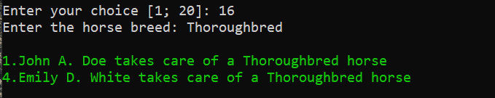

/// <summary>
/// Query 17. (Query syntax)
/// Returns the races in which the specified horses participated by nickname
/// </summary>
public static List<RaceHorseNicknameCount> GetRacesByHorseNickname(List<Race> races, List<Participant> participants, List<Horse> horses, string? nickname)
{
if (nickname is null)
{
Console.WriteLine("Nickname cannot be null");
return [];
}

IEnumerable<RaceHorseNicknameCount> res =
from r in races
join p in participants on r.Id equals p.RaceId
join h in horses on p.HorseId equals h.Id
group new { r, h } by new { r.Id, r.Number, h.Nickname } into grouped
where grouped.Any(a => a.h.Nickname == nickname)
select new RaceHorseNicknameCount()
{
Id = grouped.Key.Id,
Number = grouped.Key.Number,
HorseCount = grouped.Count(a => a.h.Nickname == nickname),
};

return res.ToList();
}



/// <summary>
/// Query 18. (Query syntax)
/// Returns the horses in which the jockey with the specified ID participated
/// </summary>
public static List<JockeyHorseInfo> GetHorsesRiddenByJockey(List<Jockey> jockeys, List<Participant> participants, List<Horse> horses, int jockeyId)
{
IEnumerable<JockeyHorseInfo> res =
from j in jockeys
where j.Id == jockeyId
join p in participants on j.Id equals p.JockeyId
join h in horses on p.HorseId equals h.Id
select new JockeyHorseInfo()
{
FullName = j.FirstName + ' ' + j.MiddleName + ' ' + j.SecondName,
HorseNickname = h.Nickname,
};

return res.ToList();
}



/// <summary>
/// Query 19. (Method syntax)
/// Returns the jockey who took the first place the most times
/// </summary>
public static JockeyWinsInfo? GetTopWinningJockey(List<Jockey> jockeys, List<Participant> participants, List<DetailResult> results)
{
JockeyWinsInfo? res = jockeys
.Join(participants,
j => j.Id,
p => p.JockeyId,
(j, p) => new
{
JockeyId = j.Id,
JockeyFullName = j.FirstName + ' ' + j.MiddleName + ' ' + j.SecondName,
ParticipantId = p.Id,
})
.Join(results.Where(r => r.Place == 1),
jp => jp.ParticipantId,
r => r.ParticipantId,
(jp, r) => new
{
jp.JockeyId,
jp.JockeyFullName,
r.Place,
})
.GroupBy(jr => new { jr.JockeyId, jr.JockeyFullName },
jr => jr.Place,
(j, p) => new JockeyWinsInfo()
{
JockeyId = j.JockeyId,
FullName = j.JockeyFullName,
WinningCount = p.Count(),
})
.MaxBy(jc => jc.WinningCount);

return res;
}

/// <summary>
/// Query 20. (Query syntax)
/// Returns jockeys who participated in the stadium of the specified country
/// </summary>
public static List<JockeyStadiumCountry> GetJockeysByStadiumCountry(List<Jockey> jockeys, List<Participant> participants, List<Stadium> stadiums,
List<Race> races, List<Address> addresses, string country)
{
if (country is null)
{
Console.WriteLine("Country cannot be null");
return [];
}

IEnumerable<JockeyStadiumCountry> res =
from a in addresses
where a.Country == country
join s in stadiums on a.Id equals s.AddressId
join r in races on s.Id equals r.Id
join p in participants on r.Id equals p.RaceId
join j in jockeys on p.JockeyId equals j.Id
group new { j, a } by new { j.Id, j.FirstName, j.MiddleName, j.SecondName, a.Country } into grouped
select new JockeyStadiumCountry()
{
Id = grouped.Key.Id,
FullName = grouped.Key.FirstName + ' ' + grouped.Key.MiddleName + ' ' + grouped.Key.SecondName,
StadiumCountry = grouped.Key.Country,
};

return res.ToList();
}

